Angle $θ$ |  | Values of the Trigonometric Ratios
Degrees | Radian | $$\sin\left(θ\right)$$ | $$\cos\left(θ\right)$$ | $$\tan\left(θ\right)$$ | $$\operatorname{cosec}\left(θ\right)$$ | $$\sec\left(θ\right)$$ | $$\cot\left(θ\right)$$
0º | 0 | 0 | 1 | 0 | Undefined | 1 | Undefined
30º | $$\frac{π}{6}$$ | $$\frac{1}{2}$$ | $$\frac{\sqrt{3}}{2}$$ | $$\frac{\sqrt{3}}{3}$$ | 2 | $$\frac{2\sqrt{3}}{3}$$ | $$\sqrt{3}$$
45º | $$\frac{π}{4}$$ | $$\frac{\sqrt{2}}{2}$$ | $$\frac{\sqrt{2}}{2}$$ | 1 | $$\sqrt{2}$$ | $$\sqrt{2}$$ | 1
60º | $$\frac{π}{3}$$ | $$\frac{\sqrt{3}}{2}$$ | $$\frac{1}{2}$$ | $$\sqrt{3}$$ | $$\frac{2\sqrt{3}}{3}$$ | 2 | $$\frac{\sqrt{3}}{3}$$
90º | $$\frac{π}{2}$$ | 1 | 0 | Undefined | 1 | Undefined | 0
120º | $$\frac{2π}{3}$$ | $$\frac{\sqrt{3}}{2}$$ | $$\frac{-1}{2}$$ | $$-\sqrt{3}$$ | $$\frac{2\sqrt{3}}{3}$$ | $$-2$$ | $$\frac{-\sqrt{3}}{3}$$
135º | $$\frac{3π}{4}$$ | $$\frac{\sqrt{2}}{2}$$ | $$\frac{-\sqrt{2}}{2}$$ | $$-1$$ | $$\sqrt{2}$$ | $$-\sqrt{2}$$ | $$-1$$
150º | $$\frac{5π}{6}$$ | $$\frac{1}{2}$$ | $$\frac{-\sqrt{3}}{2}$$ | $$\frac{-\sqrt{3}}{3}$$ | 2 | $$\frac{-2\sqrt{3}}{3}$$ | $$-\sqrt{3}$$
180º | $$π$$ | 0 | $$-1$$ | 0 | Undefined | $$-1$$ | Undefined
210º | $$\frac{7π}{6}$$ | $$\frac{-1}{2}$$ | $$\frac{-\sqrt{3}}{2}$$ | $$\frac{\sqrt{3}}{3}$$ | $$-2$$ | $$\frac{-2\sqrt{3}}{3}$$ | $$\sqrt{3}$$
225º | $$\frac{5π}{4}$$ | $$\frac{-\sqrt{2}}{2}$$ | $$\frac{-\sqrt{2}}{2}$$ | 1 | $$-\sqrt{2}$$ | $$-\sqrt{2}$$ | 1
240º | $$\frac{4π}{3}$$ | $$\frac{-\sqrt{3}}{2}$$ | $$\frac{-1}{2}$$ | $$\sqrt{3}$$ | $$\frac{-2\sqrt{3}}{3}$$ | $$-2$$ | $$\frac{\sqrt{3}}{3}$$
270º | $$\frac{3π}{2}$$ | $$-1$$ | 0 | Undefined | $$-1$$ | Undefined | 0
300º | $$\frac{5π}{3}$$ | $$\frac{-\sqrt{3}}{2}$$ | $$\frac{1}{2}$$ | $$-\sqrt{3}$$ | $$\frac{-2\sqrt{3}}{3}$$ | $$2$$ | $$\frac{-\sqrt{3}}{3}$$
315º | $$\frac{7π}{4}$$ | $$\frac{-\sqrt{2}}{2}$$ | $$\frac{\sqrt{2}}{2}$$ | $$-1$$ | $$-\sqrt{2}$$ | $$\sqrt{2}$$ | $$-1$$
330º | $$\frac{11π}{6}$$ | $$\frac{-1}{2}$$ | $$\frac{\sqrt{3}}{2}$$ | $$\frac{-\sqrt{3}}{3}$$ | $$-2$$ | $$\frac{2\sqrt{3}}{3}$$ | $$-\sqrt{3}$$
360º | $$2π$$ | 0 | 1 | 0 | Undefined | 1 | Undefined
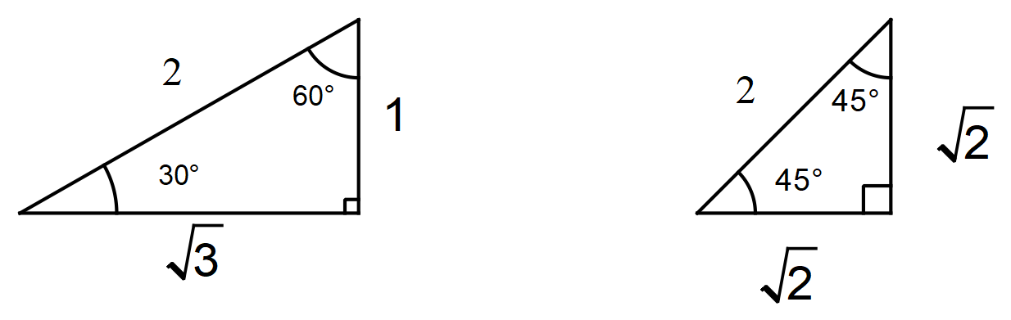A couple of useful triangles

