Pearson’s Correlation Coefficient on the Classpad

Data for Hours Worked against % of the Population going to University for 9 countries.



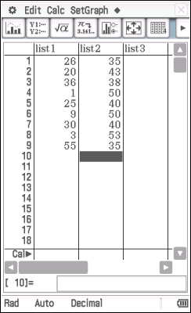

The Explanatory Variable (EV) - % at University goes in **list1**

The Response Variable (RV) – Hours worked goes in **list2**

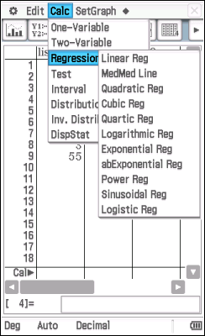

From the **Calc** menu

Choose **Regression**

Then **Linear Reg**

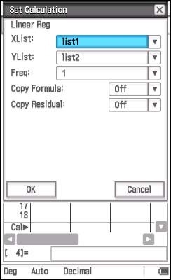

Check the settings for the calculation.

The default is shown and usually what you need.

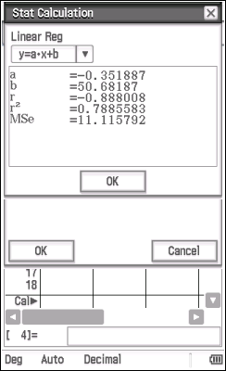

The screen that pops up has the information you need.

**Pearson’s Correlation Coefficient** is **r**.

For this data it is - 0.888008

From this we can say there is a moderate negative correlation for this data.

The **coefficient of Determination** is also found on this screen it is **r2**

This screen also gives us the information we need for the **equation of the regression line**.