Title: How Accurate is My Android speedometer?  An investigation into the ability of a mobile phone speedometer application to accurately record velocity over short distances.  Author: |  | Acknowledgements:  - : For the provision of template material, and guidance during the planning phase. Specifically, insight as so which materials would be most appropriate to use.  - d: For the transport of experimental equipment during data collection.  - : For instruction as to how to utilize appropriate analytical software. |  | References:  AppCrawl.com. (2017, 10 3). Best Speedometer Apps. Retrieved from AppCrawl.Com: http://appcrawlr.com/android apps/best apps speedometer app  The Engineer's Toolbox . (2017, 10 10). Formulas of Motion. Retrieved from The Engineer's Toolbox : https://www.engineeringtoolbox.com/motion formulas d_941.html  Brown, D. (2017). Australia Patent No. 4.9.8.  Rainey, J. (2016). Australia Patent No. 235,869
Introduction | Methodology cont. |  | Methodology cont. |  | Discussion
Aim:  The aim of the investigation is to quantitatively determine the accuracy of the speedometer app, “Speed fiend®’s’’ (Rainey, J. (2016)) ability to track velocity, over small linear distances. As a means to ascertain whether it can be justifiably recommended to athletes seeking to purchase equipment to accurately measure their velocities as a key component of stamina training.  Hypothesis:  Based on previous observations of smartphone technology it is the hypothesis that as the net velocity of the phone increases, by altering the independent variable, angle of track inclination and mass of trolley, the accuracy of the speedometer will improve to an accuracy range within 10% of the real measured velocity.  If the accuracy of the speedometer fluctuates as the independent variables, and the net velocity of the phone increases, it will suggest that mobile technology, specifically the “Speed Fiend” application is not recommendable for use by training athletes. As reliable data could not be collected.  Rationale:  Newton’s first law of motion states that an object’s acceleration, and therefore velocity at a given point, is proportional to the amount of force acting on it. Using published equations for linear motion (The Engineer's Toolbox . (2017, 10 10)), the net force acting along the plane of motion of the carriage during the experiment, (as a result of angle of inclination and mass) can be predicted as going to increase.  Reviews from technology journals, (AppCrawl.com. (2017, 10 3)) further confirm the notion that mobile applications provide an accurate measure of velocity for motorised vehicles. As an extension, observations of the same apps confirm their ability to record velocity across smaller distances. Hence, the hypothesis that smartphone applications should be able to record velocity to a reasonable degree of accuracy is supported. | 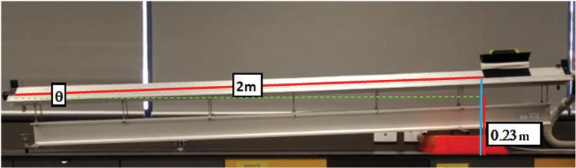  Materials:  - 2m Air track  - Air track trolley with clamps  - Weights of 50g units  - A smart phone with a speedometer app downloaded  - A second phone with a forward facing camera  - A computer with "Tracker" technology downloaded  - Air track chocks  Procedure:  - Set up the Air track and camera so that the camera can record the path of the trolley all the way along the track.  - Open the velocimetry app on the phone and place the phone in the trolley, move the trolley along the track to check that the phone is measuring velocity. If it is not, change the orientation of the phone to ensure the sensors within the phone are aligned with the plane of motion.  - Once correct orientation is determined, fasten the phone to the trolley with a clamp.  Independent Variable 1: Mass  - Weigh the trolley configuration.  - Chock one end of the track on 1 chock, then measure and record the elevation of the track from the bench. As per the diagram. Ensure the chocks are stable to prevent risk of injury from the track destabilising.  - Thus derive and record the angle of inclination as well as the mass of trolley.  - Begin recording the camera video, and turn on the velocity recording function within the app. Run the phone trolley down the track and then save the recorded velocity data, and the video as Independent variable 1, Condition 1 (I1C1). Repeat using the same condition 5 times, recording each trial.  - Increase the mass of the trolley and record the new carriage weight as I1C2. Turn on the video and velocity recorder again, and record 5 trials.  - Repeat step 8 three more times to ensure 5 different conditions for the independent variable mass are trialled and recorded.  Independent variable 2: Elevation  - Remove all additional weights from the carriage and record the elevation of the chocked end of the track above the bench, as per diagram. Begin recording video and recording velocity data on the phone, then run the carriage down the air track. Recording collected video and data as (I2C1). Repeat for 5 trials.  - Increase the elevation of the track and record new height, then run 5 trials recording collected video and data as (I2C2). Ensure stability of the elevated track. |  | - Repeat step 11 three times, increasing the height and recording data to ensure 5 conditions are collected for independent variable 2.  - Pack up equipment.  - Then, transfer all videos onto the computer, for upload onto the Tracker (or similar) analysis software.  - Use Tracker technology to analyse the acceleration of the trolley under each condition then derive the velocity reached at the end of the track for each trial.  - Compare the percentage difference between the velocity recorded by the application during each trial condition, and the analysed velocity. |  | Analysis:  Both data sets indicate strong trends, with trend gradients of 6.69%/g and 1.82%/7, respectively. These trends demonstrate that as the magnitude of the force directed along the plane of motion increased, the applications ability to accurately measure velocity increased too, by as much as 56.22%, for independent variable one, and 8.9% for independent variable two, both percentages which are importantly larger than the percentage error recorded in each experiment.  These results support the hypothesis that a speedometer application’s ability to accurately measure velocity is dependent upon the magnitude of force it experiences.  Limitations:  Although the experimental results demonstrate clear correlation between force applied in a plane of motion and percentage accuracy, the validity of these results for training athletes is limited. Because the experiment was conducted under strictly short, linear conditions the suggestion that the same relationship between force and accuracy will be relevant for training athletes is an extrapolation. Hence, the experimental results and the validity of the implications they pose for athletes cannot be acclaimed with certainty.  Conclusions:  The execution of this experiment enabled the verification of the hypothesis that: applying more force to a smartphone will improve its capacity to accurately gauge velocity. The substantiation of the hypothesis meant that the aim was met, in that it is now possible to suggest to training athletes that smartphone speedometer technology may not be reliable for the accurate assessment of velocities accomplished during training. A suggestion made on account of the clear trends observed in the data, as force applied (via independent variables one and two) impacted percentage accuracy.  Recommendations:  Although the experiment demonstrates clear correlation between force applied and percentage accuracy of the “Speed Fiend” application when tested in specific laboratory conditions, it would be advisable to trial the technologies performance under real world conditions. Conducting another experiment in the real world, monitoring athletes with smartphones secured to their bodies, as opposed to the carriage and using similar analytical techniques(Tracker), would enable the determination of a more valid measure of the applications reliability within the context of professional stamina training.
 |  |  | Results:
Graph: Independent Variable 1:

Independent Variable 2:
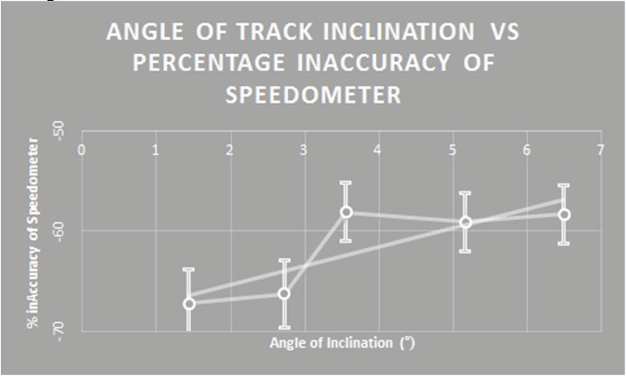

Description:
The carriages tracking along the track was consistently smooth and the increases in elevation and mass warranted discernible increases in carriage velocity. However, as the net force acting along the plane of the track increases the mobile application faltered of “glitched”, becoming increasingly unresponsive.
Hence the recording of zero velocity in the results section.
Methodology
Design:
The experimental design composes an air track and carriage, velocity recording camera, smartphone with speedometer app, and chocks and weights to manipulate the independent variables mass of carriage and track angle of inclination.
Setup has been designed to minimise the impact of the extraneous variable friction on the recorded data. By incorporating an air track into the experimental design, the friction that the carriage experiences as is travels along the plane is minimized, as a buffer of air is maintained between the carriage and the track.
The setup has also been designed to maximise the accuracy of analysed velocity through the use of video tracking technology, Tracker (Brown, D. (2017)) . The tracking camera was positioned to observe the following frame, all measurement were taken from the noted points for consistency of data analysis.

Title: VCE Physics Unit 4 Practical Investigation  A brief statement about what was investigated  Author: Mr Cevolatti |  | Acknowledgements: List people who gave assistance in your investigation, and briefly outline the way in which they contributed.  A specific and explicit acknowledgement of detailed peer, teacher,  and/or other assistance and guidance has made including description of how they have each contributed. |  | References: List all references used in your research using appropriate conventions.  Multiple references have been used and critically evaluated  appropriately in the text AND listed correctly and consistently in the bibliography using a standardised referencing system.
Introduction | Methodology |  | Results |  | Discussion
Aim:  Outline the purpose of the practical investigation, and define key terms of physics concepts specific to the investigation.  The aim of the project is clearly and concisely stated with well-defined relevant terminology and linked to large scale/broader applications.  Hypothesis:  Explicit predictions about the expected changes to dependent variables as a result of changes to independent variables, which clearly relates to the aim of the practical investigation.  A hypothesis has been put forward which makes explicit predictions about the expected changes to dependent variables as a result of changes to independent variables and implications for large scale/broader applications.  Rationale:  Some theoretical justification for any predictions made. Again, you should refer to your background research.  The hypothesis is justified and supported by a rationale based on some research of relevant background physics concepts that quantitatively relate the independent and dependent variables of the experiment. | Design:  Students have justified their design choices AND diagrams of the setup are drawn to scale with appropriate symbols and accurately labelled.  In this section you must outline the rationale behind design decisions, include diagrams of the physical setup of equipment involved in the practical investigation.  Materials:  List of all the equipment required for conducting your practical investigation.  The materials section is thorough and provides specific details of quantities and types of components used with appropriate units of measurement and technical specifications included.  Procedure:  Write down the steps used in construction and testing of your practical investigation. These steps should be clear enough that another person could accurately reproduce your experiment. This must also include a description of steps that highlight any specific health and safety precautions required.  The procedure is sufficiently detailed to allow the experiment to be accurately repeated by a non-  expert in the subject. |  | Graph:  Presentation of collected data/evidence in appropriate format to illustrate trends, patterns and/or relationships based on a data table and/or calculations presented in the logbook.  A clear, precise and accurate graph is presented which includes; detailed labels, scales and units on each axis, realistic uncertainty/error bars, and an appropriate line of best fit and associated equation.  Description:  This section must include a detailed description of any key observations of the conduct of the procedure and its outcomes and any spontaneous observations of unexpected outcomes, along with a description of any quantitative analysis and calculations recorded in your logbook.  Provides a detailed description of systematic observations of the conduct of the procedure and its outcomes and any spontaneous observations of extraneous variables or unexpected outcomes. |  | Analysis:  Analyse your findings in terms of how the experimental procedure and results addresses the hypothesis, including quantitative analysis (summary statistics, trend lines, error, and/or uncertainty)  Limitations:  Analyse your findings in terms of how the experimental procedure and results addresses the hypothesis, including experimental limitations (precision, accuracy, reliability, and validity)  Conclusions:  Conclusion – Based on your findings, state your conclusion, ensuring that it relates an analysis of the results of the experiment to the aim.  A clear and justified conclusion has been drawn that relates an analysis of the results of the experiment to the aim and acknowledges the generalisation of these findings.  Recommendations:  Recommendations – Based on your findings, a clear and justified set of recommendations is outlined, including relevant improvements, suitable applications and avenues for further research.  A clear and justified set of recommendations is outlined including, relevant improvements, suitable applications and avenues for further research, with an outline of how they might best be implemented.

