Scatter Plot on the Classpad

Data for Hour Worked against % of the Population going to University for 9 countries.



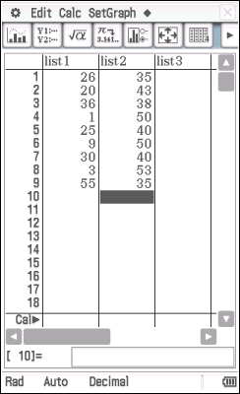

The Explanatory Variable (EV) - % at University goes in **list1**

The Response Variable (RV) – Hours worked goes in **list2**

**Tap** on the  icon to set the graph type and select the data lists to graph. **Tap** SET

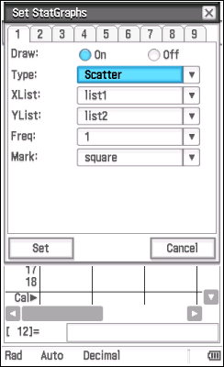The default for Type is scatter

The default for XList is list1

The default for YList is list2

**Tap** on the 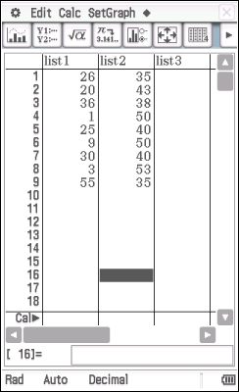 icon and the graph will be drawn.

