Sequences with the Classpad

To form a list of terms from an Explicit Relation.

Find the 4th, 8th and 20th terms in the sequence defined by t_{n} = 3n + 5

From the Menu tap Sequence. Then tap the Explicit tab.

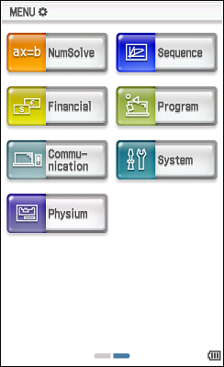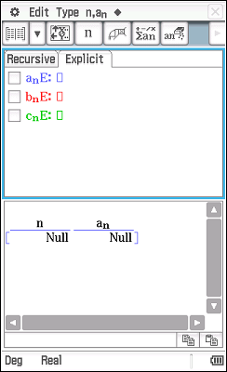

Type the Explicit Relation and press EXE. Note: the n is on the menu bar.

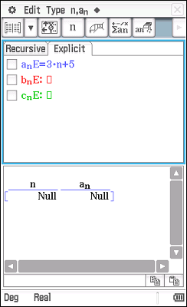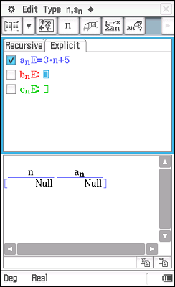

Tap the left hand icon on the menu bar.

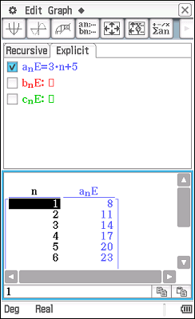

Scroll down to find the value of the terms. 17, 29, 65.

To form a list of terms from a Recurrence Relation.

Find the 4th, 8th and 20th terms in the sequence defined by t_{n+1} = 3 t_{n} + 5, t₁ = 3

From the Menu tap Sequence. Then tap the Recursive tab.
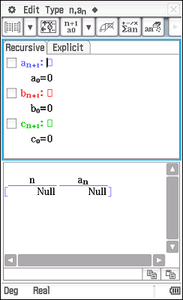

Select the initial conditions n+1 a₁ from the third icon from the left on the menu bar.
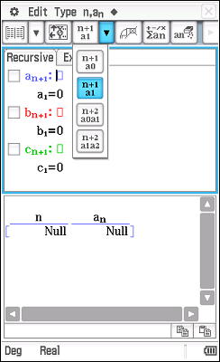

Type the Recurrence Relation and press EXE, then enter the first term and press EXE.
Note: the a_{n} is in the top menu bar.
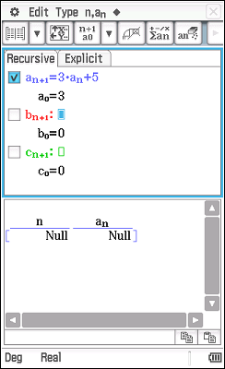

Tap the left hand icon on the menu bar.
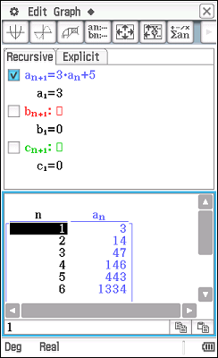

Scroll down to find the value of the terms. 146, 12026, 6.4 × 10⁹

